Theory of Action

If we…
adopt a Community School Model
build strong relationships focused on each person’s health, safety, and engagement, while supporting, challenging, and connecting them to the school and broader community and;
work as a flexible and adaptable learning community, utilizing data to support continuous improvement and incorporate a collaborative leadership model
design joyous, rigorous, meaningful, and multicultural learning experiences
expand, strengthen, incorporate and harness the power of meaningful relationships with our families and the broader community and;
rely on high-quality, standards aligned instructional resources with differentiated models, and scaffolded supports with high expectations for all students;

Then we will…
create a shared version of success that will spark the desire to learn and achieve for all members of our school community, instilling a passion for lifelong learning in each student while simultaneously fostering personal responsibility. Our students will possess the ability to think critically, adaptively, and humanely in order to meet the needs of tomorrow.

Dr. Albert B. Consentino Middle School Improvement Plan
2025-2028
Vision
Our vision of inclusive education is a system that ensures that the families and the community in which we live and work are active participants in the education of the students we are responsible for. We strive to foster an environment where inclusion branches out from a central trunk of community, where those involved, staff and families, feel seen and heard in relation to the educational experience that takes place at Consentino. We actively seek participants to collaboratively lead and plan for culturally responsive learning experiences under the shade of a Community School model.
Mission
The Dr. Albert B. Consentino School's mission is to create a rigorous learning environment that encourages high expectations for academic and personal success. With our staff, community and partners we will explicitly teach students that we are all accountable for our our actions, our school community and learning. We will promote a safe, orderly, and supportive environment where all learners are equipped with the tools needed for their own academic and personal success.

Shared Values

Positivity
Respect
Integrity
Determination
Enthusiasm

Consentino Middle School Highlights and Challenges 2025-2028

Highlights | Challenges
Drastic decrease in chronic absenteeism, surpassing DESE targets | A decrease in the achievement of multilingual learners
Incorporate and Support Community School Initiative | Engaging all stakeholders and communicating the principles of Community Schools
Incorporation of co-teaching, Intervention for all students, and support for high-achieving students | Training staff and engaging students
Substantial Progress Towards DESE targets | Limitations in staffing, particularly English Language Development Teachers. Increase the number of subject-certified staff.  Incorporate more time in tier one instruction for Special Education Students
Improved performance in Mathematics and Science, Technology & Engineering | Higher than normal staff absences and unavailability of substitute teachers. Lack of subject-certified staff
Progression of the school building project

Consentino Middle School Highlights and Challenges 2025-2028

Highlights | Challenges
Drastic decrease in chronic absenteeism, surpassing DESE targets | Higher than normal staff absences and unavailability of substitute teachers
Increased social-emotional support and programming, as well as new clubs and other student interest groups | Static achievement levels for ELA (grades 5 and 7) and Math (grades 5 and 7). Decrease in the achievement of special education students
Substantial Progress Towards DESE targets | Regression in achievement for both ELA and Math in Grade 7
Improved progress by multilingual learners | A decrease in the achievement of long-term ML students
Growth in Science for Grades 5 & 8
Growth in Grade 5 ELA following Witt & Wisdom implementation and continuing growth in Math SGP

Consentino Middle School Strategic Objectives 2025-2028

Strategic Objective #1: Core Instruction (Tier 1 Instruction)  Aligned with District Improvement Plan Strategic Goals 1, 2, 3 | Strategic Objective #2: Multi-Tiered Systems of Support (MTSS)  Aligned with District Improvement Plan Strategic Goals 1, 2, 3, 4
Build strong relationships with each student and provide each student with the academic, social, emotional, and behavioral health support necessary for success. | Build strong relationships with each student and provide each student with the academic, social, emotional, and behavioral health support necessary for success.
Provide social-emotional Tier 1 support and instruction through classroom lessons facilitated by School Counselors. | Build a Student Support Team (SST) with a clear referral and review process. Improve communication and collaboration on SST teams.
Build strong Core Instruction (Tier 1) throughout the school, including a shared language for co-planning (including objectives) and assessment through walk-through observations and support of content coaches. | Continue to implement high behavioral expectations throughout the school and work to decrease the use of exclusionary discipline practices, instead relying on collaborative problem-solving and restorative practices.
Implement strong Sheltered English Immersion (SEI) strategies universally to support not only Multilingual Learners but all students. | Implement Tier 2 and 3 intervention practices with clear resources for academics and social-emotional wellness.
Use data cycles with an emphasis on student work products to improve Tier 1 instruction and intervention.. | Use data cycles to support student and staff learning in order to improve Tier 1 instruction and identify Tier 2 and 3 interventions as needed.
Build a schedule that allows Students with Disabilities and Multilingual Learners to access the curriculum without being removed from the classroom during Core Instruction (Core+More). | Expand and strengthen meaningful partnerships with families and the community, including consistent two-way communication to support the “whole child” both at school and within the community.
Implement rigorous, research-based, and standards-aligned High-Quality Instructional Materials across Core Academics (i.e. Wit & Wisdom, StudySync, EurekaMath2). | Strengthen inclusive and differentiated instructional practices throughout the school, including co-teaching practices.
Strengthen inclusive and differentiated instructional practices throughout the school, including co-teaching practices.. | Work with the counseling staff to implement the mental health support and referral system, Universal Mental Health Screening, and a strong partnership with community agencies.
Create opportunities for Teacher Leadership through the Lead Teacher and Instructional Leadership Team programs and presentations. Continue to build on the Peer Observation Program in order to share instructional best practices. | Continue to build opportunities for students to have meaningful involvement in co- and extracurricular activities during and outside of the school day.

Strategic Objective #1: Core Instruction (Tier 1 Instruction)- Aligned with District Improvement Plan Goals 1,2 and 3

SMARTIE Goal: Consentino Middle School will continue to improve student growth and achievement in an equitable and challenging environment so that all students, regardless of background, achieve their full potential by providing strong Tier 1 core instruction utilizing rigorous high-quality instructional materials aligned to state standards.

Strategic Objective Action Items | Time Frame | Person(s) Conducting Activity / Person Ensuring Implementation | Materials/ Professional Development/ Staffing needed | Assessment /Goal | Date  Completed/  Ongoing
1.1: Modification of Instructional Playbook | SY25 | - Instructional Coaches  - School Leadership Team  - Instructional Leadership Team (ILT) | - Funding for ILT/Lead Teachers to work outside the school day.  - Access to district/school data  - Professional development for co-teaching | - An Instructional Playbook is modified based on ILT review and shared with staff. The playbook contains foundational Tier 1 strategies as well as recommended Tier 2 and 3 strategies. | Fall 2025: Ongoing
2.1:Implementation of high-quality instructional materials across core content areas | SY25 | - Instructional Coaches  - SS/Sci Lead Teachers  - School Leadership Team  - District Curriculum Supervisors | - The district provided curriculum resources and ongoing professional development to support the resources. | - Evidence-based and standards-aligned curriculum resources are in place across all core content areas.  - All staff members, including sub-separate programs, exclusively use the resources with fidelity and are on pace with school and district pacing expectations. | Fall 2025: Ongoing
3.1: Implementation of strong Tier 1 instructional practices throughout the school. | SY25 | - Instructional Coaches  - SS/Sci Lead Teachers  - School Leadership Team  - District Curriculum Supervisors  - All staff | - Professional development to support Co-teaching and lesson planning, including creating strong content objectives, language objectives, and planning strong, standards-aligned Tier 1 instruction.  - Creation of universal school-wide anchor charts, visuals, and shared language for teaching, particularly in reading and writing | - Strong SEI and differentiated instructional practices are observed throughout the school.  - Co-teaching practices are observed throughout the school in classrooms where there is more than one adult.  - Rigorous and relevant, standards-aligned content and language objectives are posted and referred to throughout instruction across the school.  - Pacing reflects school and district expectations.  - The need for Tier 2 and 3 interventions decreases due to strong Tier 1 instruction.  - Student thinking is visible. Students are doing the majority of the speaking in the classroom in the form of academic discussion with educator support. | Fall 2025: Ongoing
4.1: Build out the Student Support Team (SST) process. | SY25 | - School Leadership Team  - Student Support Coordinator  - Members of the Special Education and ML Team  - Instructional Leadership Team  - Counseling Team | - PRIDE Playbook  - District MTSS Handbook  - School MTSS Playbook  - DCAP  - Instructional Playbook | - Clear referral processes  - Ongoing data analysis and progress monitoring of referrals.  - A reduction in Tier 2 and 3 interventions due to stronger Tier 1 instructional practices. | Fall 2025: Ongoing
5.1: Implementation of Restorative Justice practices in conjunction with the PRIDE program to create an inclusive environment that values student participation. | SY25-SY28 | - All staff  - All Students  - Supervised by the School Leadership Team and the Student Support Coordinator  - Climate Committee  - Student Council Representative | - Restorative Justice Training through Suffolk University  - Schoolbrains  - Climate Committee funding  - Access to the PASS program | - Increase student voice in the school  - Increased positive feedback on student, staff, and family surveys.  - Decrease in office discipline referrals.  - Decrease in the use of exclusionary discipline.  - A substantial decrease in physical altercations and suspensions, plus an observable improvement in school climate. | Fall 2025: Ongoing
6.1: Implementation of SMARTIE goal process to all educators | SY25 | - All staff, overseen by the School Leadership Team | - TeachPoint  - DESE SMARTIE goal template  - Ongoing professional development on building equitable and inclusive practices in instruction | - Rigorous data-driven goals are in place for all educators with an emphasis on equity and inclusivity.  - Improved Tier 1 instruction.  - Monthly walk-throughs using TNTP and district guidance | Fall 2025: Ongoing

Strategic Objective #2: Multi-Tiered Systems of Support (MTSS)- Aligned with District Improvement Plan Goals 1-4

SMARTIE Goal: Consentino Middle School will continue to build a strong Multi-Tiered System of Support in order to support the “whole child” as a learner and individual, regardless of student background.

Strategic Objective Action Items | Time Frame | Person(s) Conducting Activity / Person Ensuring Implementation | Materials/ Professional Development/ Staffing needed | Assessment/Goal | Date  Completed/  Ongoing
2.1: Build out the Student Support Team (SST) and systems | SY25 | - School Leadership Team  - Student Support Coordinator  - Members of the Special Education and ML Team  - Instructional Leadership Team  - Counseling Team | - PRIDE Playbook  - District MTSS Handbook  - School MTSS Playbook  - DCAP  - Instructional Playbook | - Clear referral processes using the Schoolbrains platform.  - Ongoing data analysis and progress monitoring of referrals.  - A reduction in Tier 2 and 3 intervention due to stronger Tier 1 instructional practices.  - A reduction in Student Support Team referrals due to strong Tier 1 instruction and successful Tier 2 and 3 intervention implementation.  - Increased discharges of Special Education services. | Fall 2025: Ongoing
2.2: Continued implementation of the PRIDE program and exploration of restorative practices | SY25-SY28 | - All staff  - Supervised by the School Leadership Team and the Student Support Coordinator  - Climate Committee | - Climate Committee funding  - Access to the PASS program  - Restorative Justice Training at Suffolk University | - Increased positive feedback on student, staff, and family surveys.  - Decrease in office discipline referrals.  - Decrease in the use of exclusionary discipline.  - A substantial decrease in physical altercations and observable improvement in school climate both in terms of data and anecdotal observation. | Fall 2025: Ongoing
2.3: Provide Social-Emotional Learning (SEL) support at Tier 1, 2 and 3 | SY25 | - School Leadership Team  - Counseling Team  - Community Service Providers | - Universal Mental Health Screening  - Partnership with outside agencies  - Mental Health referral system  - Evidence-based SEL curriculum | - Implementation of DCAP and Tier 1 SEL curriculum across the school.  - Professional development for staff on how to address students facing social and emotional barriers in a proactive manner.  - Professional development for staff on Restorative Justice Practices and community circles.  - Decrease in student conflict and increased feeling of community as evidenced by student surveys and anecdotal observation. | Fall 2025: Ongoing
2.4: Strengthen Tier 1 instructional practices throughout the school and enhance Tier 2 and 3 interventions | SY25 | - Instructional Coaches  - SS/Sci Lead Teachers  - School Leadership Team  - District Curriculum Supervisors  - All staff | - Professional development for teachers to increase student voice and decrease teacher talk.  - Writing strong content and language objectives and planning strong, standards-aligned Tier 1 instruction.  - Creation of universal school-wide anchor charts, visuals, and shared language for teaching, particularly in reading and writing | - Strong SEI and differentiated instructional practices are observed throughout the school.  - Incorporation of co-teaching strategies  - Rigorous and relevant, standards-aligned content and language objectives are posted and referred back to throughout instruction across the school.  - Pacing reflects school and district expectations.  - The need for Tier 2 and 3 interventions decreases due to strong Tier 1 instruction.  - Student Support Team referrals decrease due to successful, strong Tier 1 instruction and Tier 2 and 3 interventions.  - Student thinking is visible. Students are actively, verbally explaining, defending, and making sense of their academic ideas with each other. Students are doing the “heavy lifting” with educator support. | Fall 2025: Ongoing
2.5: Reduce chronic absenteeism | SY25-25 | - School Leadership Team  - Counseling Team  - District Attendance Supervisor | - Creation of a school attendance panel that meets every 2 weeks with the Administrative team.  - Partnership with District Attendance Supervisor to create attendance contracts for at-risk students  - Participation in district-wide Attendance Panel  - Create opportunities for incentives to celebrate attendance improvement  - Practice regular home visits in conjunction with the Community School Coordinator | - Reduction in chronic absenteeism to 15% or less. | Fall 2025: Ongoing
2.6: Enhance relationships with community service providers and work to create more opportunities for student involvement in meaningful activities in and out of school | SY25-28 | - School Leadership Team  - Counseling Team  - Staff advisors | - Continued partnership with YMCA, YWCA, and Haverhill Police Department  - Continued partnership with Lahey Behavioral Health  - Funding for student activities | - Multiple clubs, co-curricular, and athletic organizations within the school.  - Partnership with Boys & Girls Club, YMCA, and YWCA to provide meaningful out-of-school activities for students.  - Continued partnership with the Haverhill Police Department to present the GREAT program.  - Partnership with HP3 to allow students to explore careers and life opportunities. | Fall 2025: Ongoing
2.8: Work to enhance student voice within the school | SY25 | - School Leadership Team  - Students | - Regularly survey students on school culture and | - Creation of the Principal’s Student Advisory Council with regular ongoing meetings and sponsored events. The Cabinet will reflect the diversity of our student population.  - Continued support of the Student Council, the President of which will serve on the School Council. | Fall 2025: Ongoing
2.9: Continue efforts to recruit and retain a diverse team of high-quality staff members that reflect the identities of our students | SY25-28 | - School Leadership Team  - District Human Resources Department | - Partnership with UMASS Lowell and Merrimack College to provide opportunities for support staff advancement  - Participation in District-sponsored and other job fairs  - Continued partnership with members of the community to recruit local residents | - Continued diversification of faculty and staff to reflect the identities of our students. | Fall 2025: Ongoing

School-Wide Initiatives

Charger PRIDE
The Consentino Middle School continues to implement a Community Schools Model. The school utilizes the SchoolBrains platform to capture and analyze positive and negative behaviors. The school’s PRIDE Playbook lays out a clear continuum of positive and negative consequences for behavior. The school regularly reinforces appropriate behaviors via “earned unexpected” and planned rewards.

Teacher Leadership
Each teaching team (ELA, Math, Science, Social Studies/Civics, Integrated Arts, and Special Education) has a teacher who represents the team on the Instructional Leadership Team (ILT). The Lead Teacher facilitates the monthly collaboration period for the team, which centers around the “whole student” by looking at student performance via iReady and other assessments, behavior, and attendance data. Team-based interventions and enrichment, as well as strategic adjustments to Tier 1 instruction, are made during this time.

Extra-Curricular Enhancements & Student Voice
The school continues to build out its offerings of extra-curricular and athletic programs for students. During the 2025-2026 School year, the school will continue to build its existing clubs and sports, particularly the visual and performing arts programming, by organizing the school’s first musical production and a significant enhancement of the school’s choral program. Additionally, the school will start a Principal’s Student Advisory Cabinet consisting of 7th and 8th-grade students to foster student leadership and voice within the school community. Beginning in SY25, the school will implement a Student Council with elected class representatives and building leaders. The school will continue to build its fine and performing arts programming.

Tier 1 Instructional Practices
During the 2025-2026 School Year, the Consentino School will continue to build its Instructional Leadership Team and revise the Instructional Playbook to support teaching and learning. The school will concentrate on the creation of clear, rigorous, and standards-aligned learning objectives following a “what, why, how” format. The school will partner with the district’s Multilingual Learner Education department to incorporate Sheltered English Immersion (SEI) strategies across the school.

In SY25, the school will continue to implement high-quality instructional materials such as Witt & Wisdom, StudySync, EurekaMath2, Networks, Impact, and STEMScopes with fidelity and the appropriate scaffolds to support all learners.

In addition to the traditional educator evaluation system, the school’s Leadership Team will implement an observation and debrief cycle for all educators with a focus on student work product during debriefs.

The school, along with district leadership, will continue to implement regular walkthroughs to gauge instructional processes and plan improvement in a non-evaluative learning process.

Time on Learning
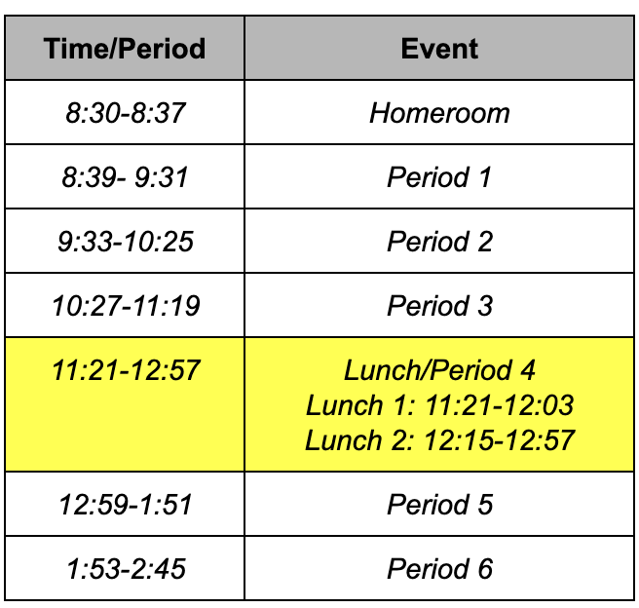
Consentino Middle School currently has a six-day rotating schedule (A-F days) consisting of six periods. Each period is 53 minutes long with 2 minutes of passing between periods. Students participate in ELA, Math, Science, Social Studies, Specials, and a What I Need (WIN) block each day. Students take Specials on a Trimester basis with two new Specials each Trimester. Currently, the school offers two distinct gym and art classes, general music, health, technology, and library. Additionally, students can opt to participate in the band. Students in the band are pulled from their classes to participate.

The WIN block is used to provide pull-out Special Education and ML services as well as intervention and enrichment. A major facet of the WIN block is the iReady Diagnostic Assessment and accompanying MyPath.

In addition, students have lunch and recess each day.

Capital Improvements

In 2019 the City of Haverhill was accepted into the Massachusetts School Building Authority’s (MSBA) school building program. After an arduous needs assessment, it was ultimately decided that an all-new Consentino Middle School would be built on the existing athletic fields while the existing Consentino remains occupied by students. When the new building is complete, the old building will be demolished and repurposed for the new athletic field. The anticipated enrollment of the new facility is over 1,000 serving grades 5-8.

The City of Haverhill passed a debt exclusion via special election in June of 2023 to finance the City’s portion of the $157,000,000 project.

The new Consentino Middle School is scheduled to open its doors to students in the spring of 2026.
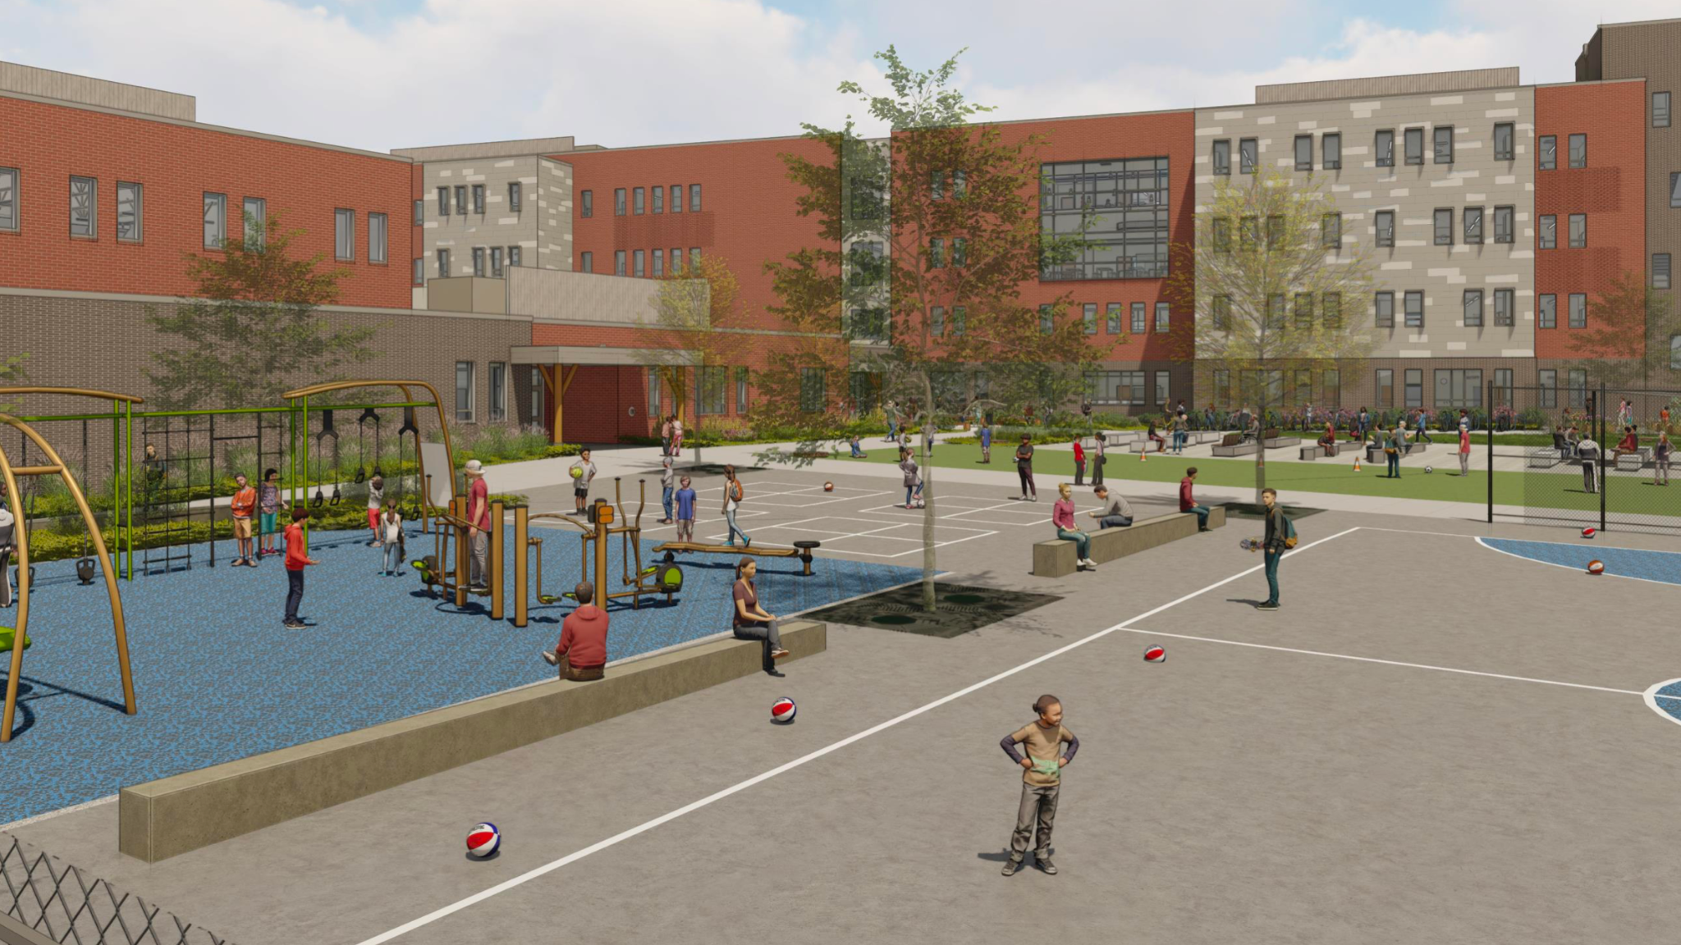
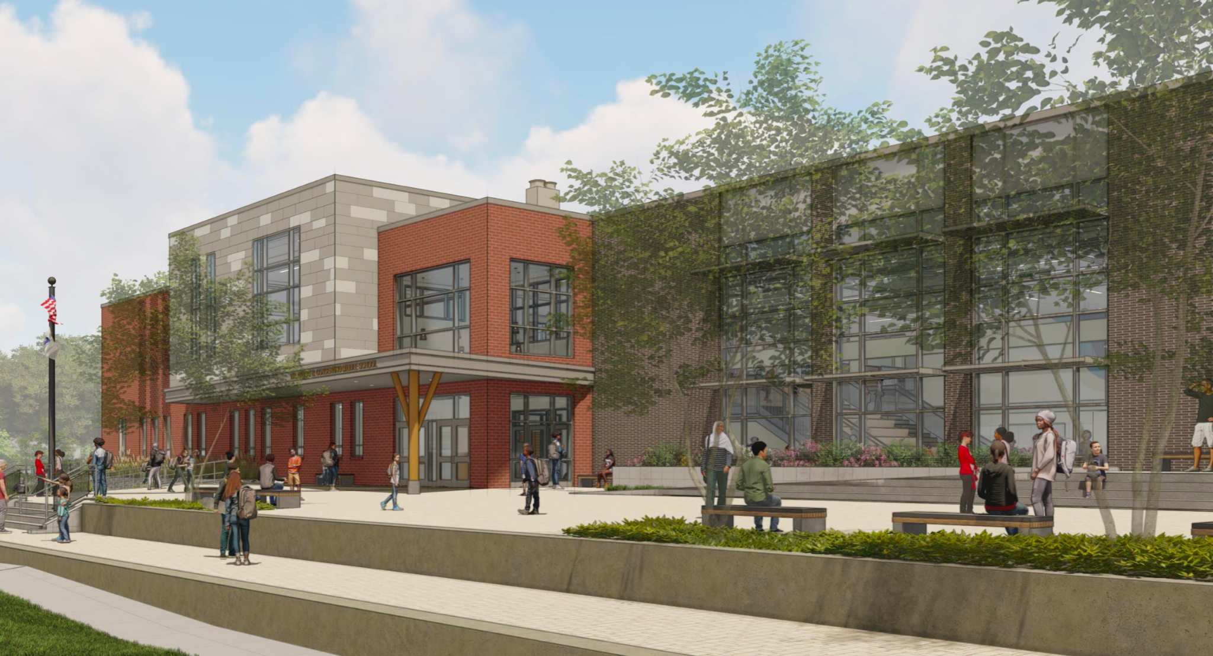
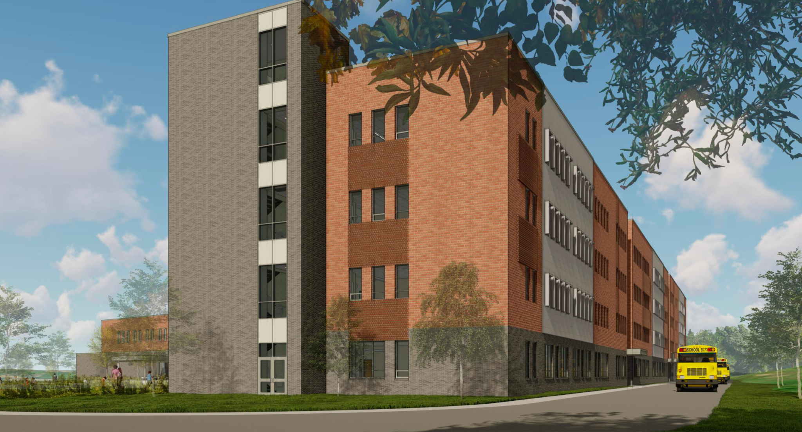
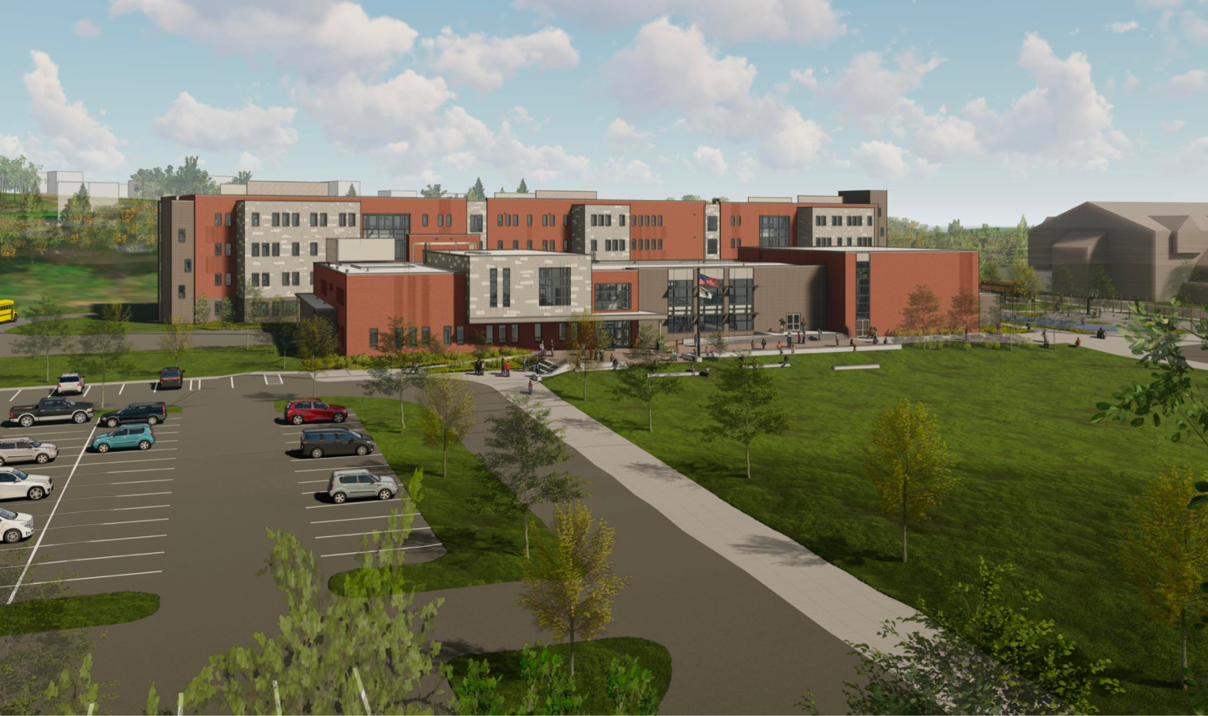
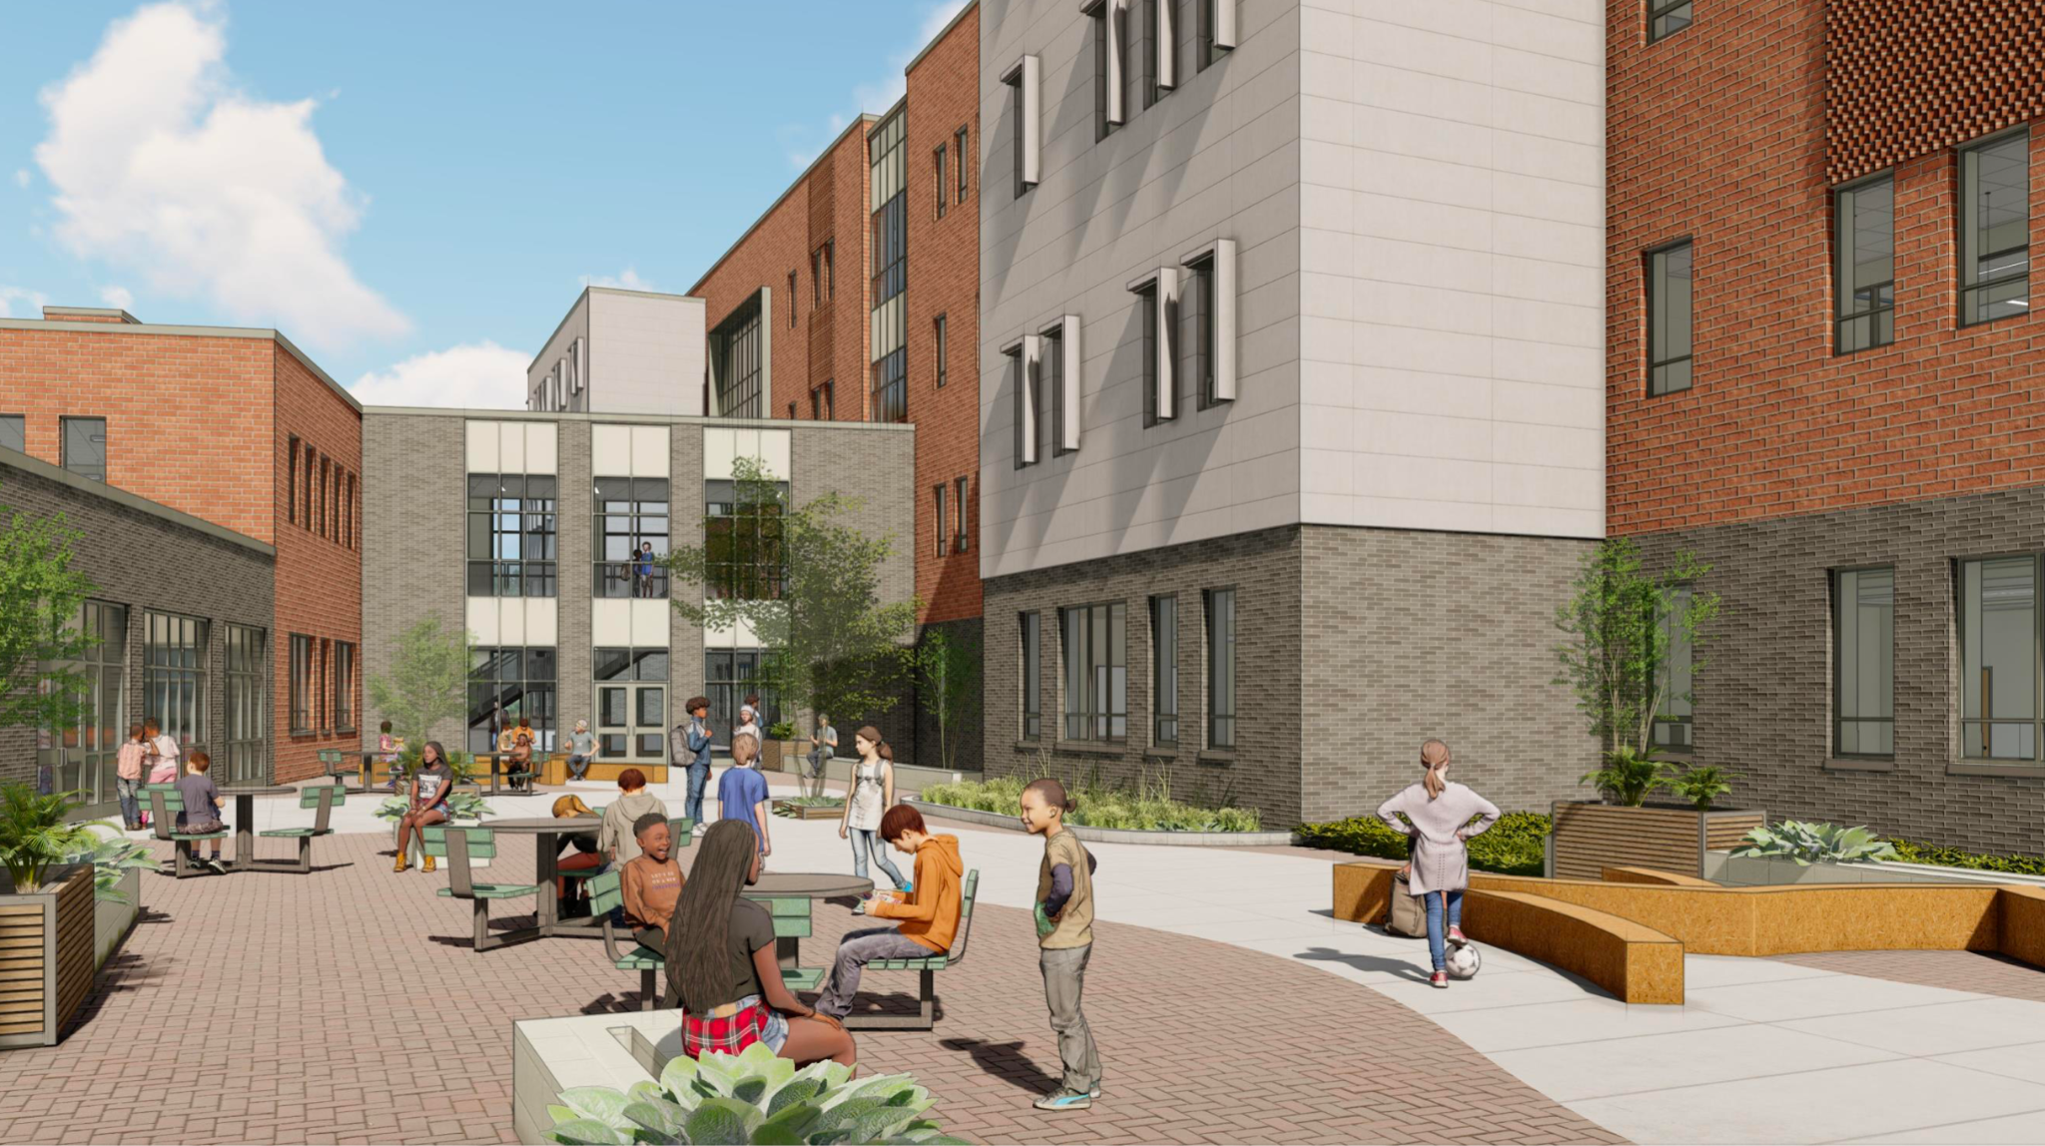

Images of the proposed new Consentino Middle School produced in Fall 2023
Accountability Summary
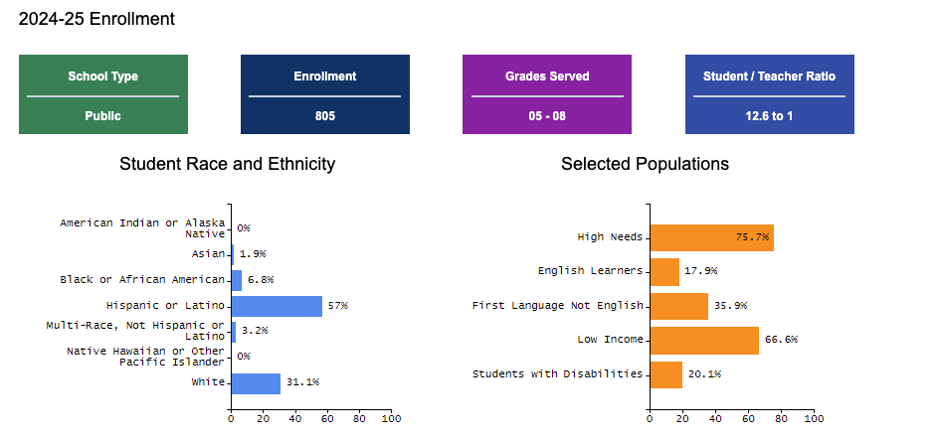
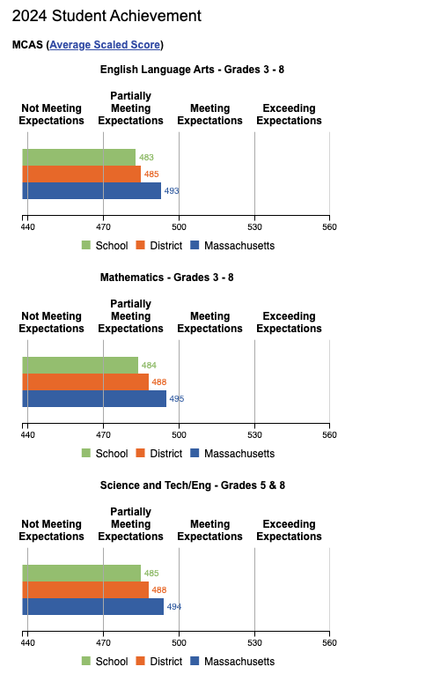
Data compiled from Massachusetts Department of Elementary & Secondary Education School and District Profiles:
Massachusetts School and District Profiles. Contact Information - Consentino Middle School (01280100). (n.d.).
https://profiles.doe.mass.edu/general/general.aspx?topNavID=1&leftNavId=100&orgcode=01280100&orgtypecode=6
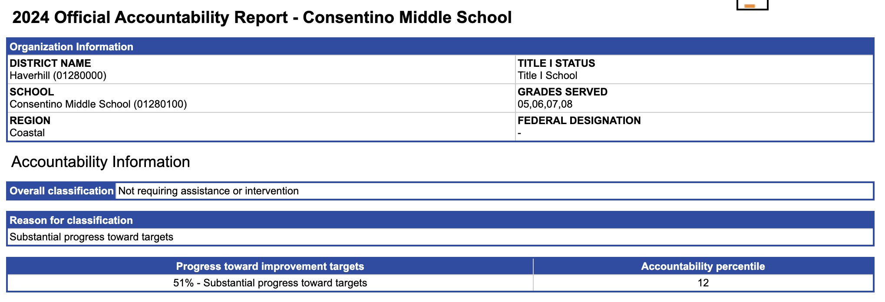
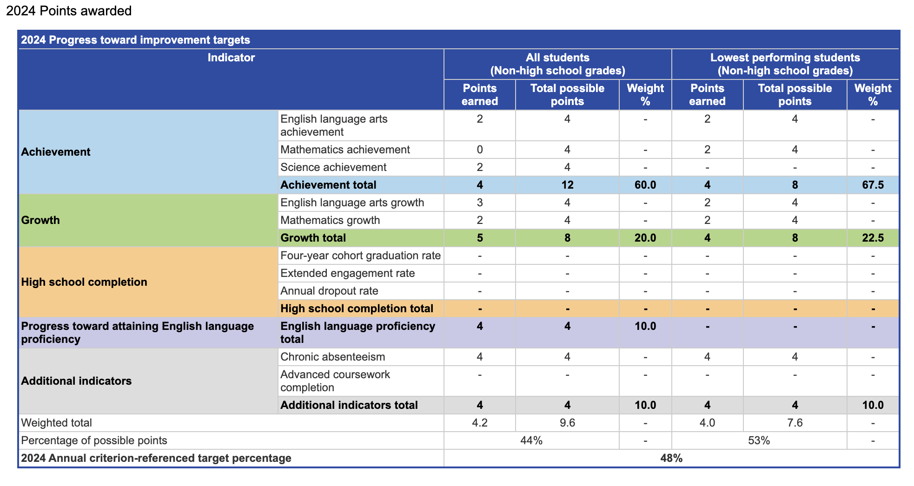

Consentino Middle School Improvement Council 2025-2028

Chairperson:
Eileen Doherty, Principal _____________________________

Co-Chairperson:
Lynette Hickey, Parent
______________________________

Recording Secretary:
Kimberly Costanzo, Parent/ESP ______________________________

Faculty & Staff:
Colleen Wrisley, Grade 7 Science ______________________________
Laurel Tomasz, Math Coach ______________________________
Brendon Parker, Assistant Principal _____________________________
Beth Gibson Assistant Principal ______________________________
Jenniffer Cabrera-Vicente, Community Schools Coordinator/Parent _______________________________

Families:
Maritza Martinez-Cabrera ______________________________
Yessenia Ynoa ______________________________
Joanna Dix ______________________________
Robert Mohns ______________________________
Richard Psarros ______________________________
Chrystal Pinero ______________________________
Richard Psarros ______________________________
Maria Martinez Geoffroy ______________________________

Community Representative
Kieth Boucher, Founder, MakeIT Haverhill ______________________________
Renee Omalade, United Way of Massachusetts Bay ______________________________

Student Representative
, Student Council President ___________________________

